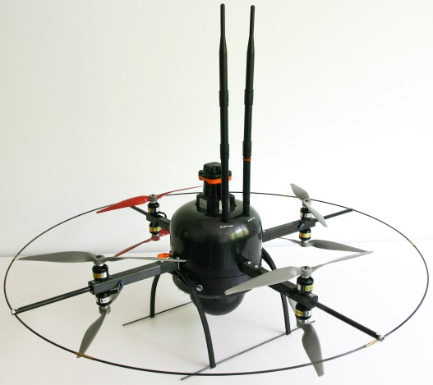Flight manual for the Mikrokopter device

C:\Users\jboerding\AppData\Local\Microsoft\Windows\Temporary Internet Files\Content.Word\nifti-logo-red.tiff

NIFTi

Natural Human-Robot Cooperation in Dynamic Environments

www.nifti.eu

Josef Börding

Fraunhofer Institut für Intelligente Analyse- und Informationssysteme – IAIS

Abteilung Adaptive Reflective Teams – ART

Schloss Birlinghoven

53754 Sankt Augustin

josef.boerding@iais.fraunhofer.de

November 2013

Index

1 Introduction 4

1.1 Mikrokopter as a flight device 4

1.2 Orientation, movement, and flight control 4

2 Preparations 5

2.1 Loading the battery using a Ultramat 8 charger 5

2.2 Loading the battery using a Ultramat 14 plus charger 5

2.2.1 Connect the battery 5

2.2.2 Charger configuration 6

2.2.3 End charging 6

2.3 Insert battery into Mikrokopter (Mikrokopter without housing) 7

2.4 Insert batteriy into Mikrokopter (Mikrokopter with housing) 7

2.5 Battery exchange (hot swap) during service 8

2.6 Mikrokopter switch on 9

2.7 Remote control switch on / Switch positions 9

2.8 Mikrokopter calibration 10

2.9 Mikrokopter start 10

3 Fly the Mikrokopter 11

3.1 Emergency Stop / Shut down the Mikrokopter 11

3.2 Mikrokopter manually remote control 12

3.3 Semi-automatic control 13

3.3.1 Automatic height control 14

3.3.2 Alignment independent control (care free) 15

3.3.3 Automatic GPS positions control 16

3.3.4 Switch off the automatic GPS positions control 17

3.3.5 Automatic GPS homing 17

4 Annex 18

4.1 System check before start-up 18

4.1.1 Table check 18

4.1.2 System check using a PC 19

4.2 Checkliste prior to a flight 21

4.3 Maintenance logbook 22

4.4 Flight logbook 23

4.5 Tool set and replacement equipment box 24

4.6 Wearing parts 25

4.7 Ready indicator 26

5 Quick Reference 27

# Introduction

Continuous and intensive flight training is recommended for a stable navigation of a Mikrokopter. Many hours of training are needed to become a good pilot.

## Mikrokopter as a flight device

Due to the round construction of the Mikrokopter the front position for a forward flight is marked by a red propeller.

## Orientation, movement, and flight control

|  |  |  |
| --- | --- | --- |
|  |  | |
|  | Left control stick   * Lift/Descent (Gas)   **⬄** Rotate (Yaw) | Right control stick  **⇳** Forward/Backward flight (Pitch)  **⬄** Left/Right flight (Roll) |

# Preparations

## Loading the battery using a Ultramat 8 charger

|  |  |
| --- | --- |
|  | 1. Connect the charging cable in correct polarity. 2. Connect the control cable in correct orientation. Black line = GND at Pin1. 3. Connect the charger to electric socket. 4. Set charging current to **1,5A**. 5. Start charging by pressing the **LiPo** button.   Charging is completed when the charger signals continuously loud beeps. |

## Loading the battery using a Ultramat 14 plus charger

### Connect the battery

|  |  |
| --- | --- |
|  | 1. Connect the charging cable in correct polarity. 2. Connect the two pole cable sockets. 3. Connect the control cable in correct orientation. Black line = GND at Pin1. 4. Connect the charger to electric socket. 5. Start charging by pressing the ENTER/START button. |

### Charger configuration

|  |  |
| --- | --- |
|  | 1. Connect the charger to electric socket. 2. Use button PROG/MODE to select **LiPo manual**. 3. Push the ENTER/START button to select the charging current (selected value is blinking). Use buttons DEC or INC to adjust the charging current to **1,0 A**. 4. Push the ENTER/START button to select the charging capacity (selected value is blinking). Use buttons DEC or INC to adjust the charging capacity to **6600m A**. 5. Start charging by holding the ENTER/START button for some seconds. |

### End charging

|  |  |
| --- | --- |
|  | The display prints END in the upper left corner when charging is finished. Charge current is 0 mA. |

## Insert battery into Mikrokopter (Mikrokopter without housing)

|  |  |
| --- | --- |
|  | 1. Insert the battery into the battery slot. 2. Connect the battery cables (high current cable and one balancer cable) in correct polarity. 3. Fix the battery in the battery slot by using sticky tape. 4. Fix free cables at the battery slot by using sticky tape.   The Mikrokopter is ready for flying. |

## Insert batteriy into Mikrokopter (Mikrokopter with housing)

|  |  |
| --- | --- |
|  | 1. Carefully insert the battery into the battery slot. 2. Connect the battery cables (high current cable and one balancer cable) in correct polarity. 3. Put free cable into the battery slot. 4. Close the battery slot by fixing the door using a knurled-head screw.   The Mikrokopter is ready for flying. |

## Battery exchange (hot swap) during service

A low battery may be exchanged without shutting down the UAV system. An interruption free service is possible only if the following steps are performed in the given order.

|  |  |
| --- | --- |
| 1 | 1. Verify that one balancer cable is connected to the battery balancer plug of the UAV battery. 2. Carefully pull out the battery of the UAV’s battery storage slot. |
| 3 | 1. Disconnect the high current plug from the UAV battery.  *Now the UAV is only low level powered by the old battery. The current via the balancer plug is suitable for running the system without motor power.* |
| 4  5 | 1. Connect the free balancer cable to the new battery.  *UAV now is low level powered by the new battery. The old battery will not be charged.* 2. Disconnect the balancer cable from the old UAV battery. *The old battery now is completely disconnected and ready to be charged.* 3. Connect the high current plug to the new battery. *UAV now is full powered by the new battery.* 4. Carefully put new battery and cables into the battery slot. 5. Close the battery slot by fixing the door using the knurled-head screw. 6. The Mikrokopter is ready for flying again. |

## Mikrokopter switch on

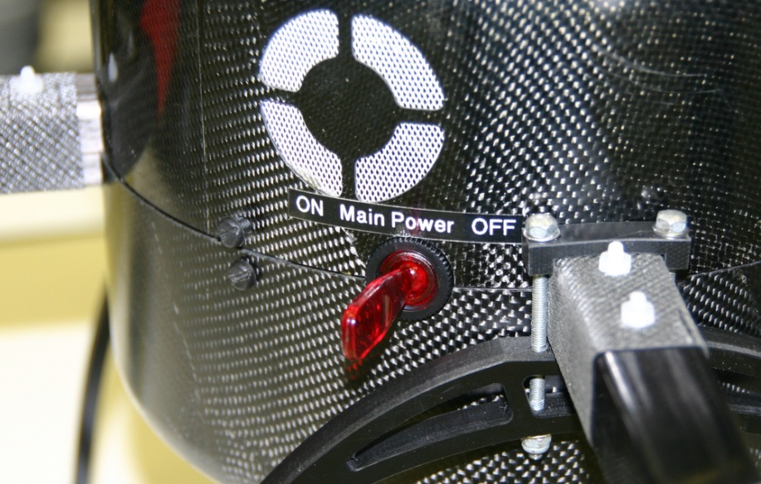

After switching on the Mikrokopter will give a short beep for every motor. With each beep the motor will move the respective propeller.

## Remote control switch on / Switch positions

|  |  |
| --- | --- |
|  | The remote control is configured for use with Mikrokopter. If not, see the user’s manual of the remote control.  All switches along the remote control housing ① ② ③ ④ are in down positions or in positions away from the pilot.  Switch on the remote control by pushing the central ON/OFF switch.  Charge the remote control prior to use.  Do not use the remote control while charging. |

## Mikrokopter calibration

|  |  |
| --- | --- |
|  | Make sure the Mikrokopter is standing in a horizontally leveled position (use a water level).  Make sure that the motors are switches off.   1. Move and hold the left control stick into the upper left corner (listen to three beeps) and wait, until the Mikrokopter responds with a single beep. 2. Move and hold the left control stick into the upper right corner (listen to three beeps) and wait, until the Mikrokopter responds with a single beep. |

## Mikrokopter start

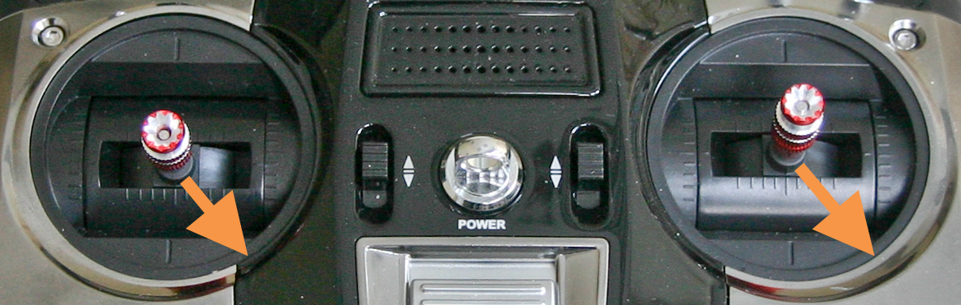

Move and hold the left and the right control stick at the same time until all propellers of the Mikrokopter are running properly.

While starting the motors the **current GPS position will be saved** (see 3.3.5 Automatic GPS homing).

# Fly the Mikrokopter

## Emergency Stop / Shut down the Mikrokopter

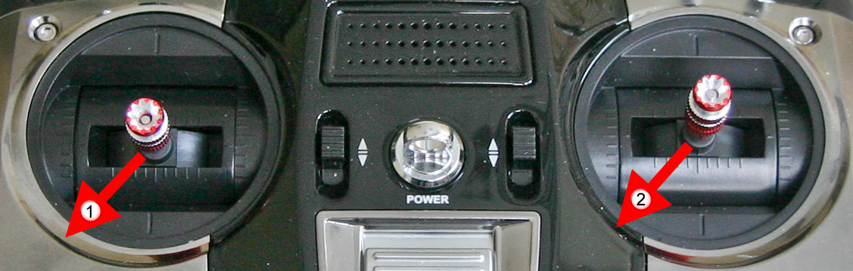

First move the left control stick to the lower left corner, hold it, and then move the right control stick to the lower left corner and wait until all motors have stopped.

**Never stop all motors if the Mikrokopter is flying high. It will crash to the ground immediately.**

## Mikrokopter manually remote control

|  |  |  |
| --- | --- | --- |
|  | All outside switches position are pointing „down“ (seen from the pilot) or „away from the pilot“. | |
|  |  | |
|  | Left control stick   * Lift/Descent (Gas)   **⬄** Rotate (Yaw) | Right control stick  **⇳** Forward/Backward flight (Pitch)  **⬄** Left/Right flight (Roll) |

## Semi-automatic control

Semi-automatic control makes flying the Mikrokopter easier in some aspects.

|  |  |
| --- | --- |
| **Automatic height control** | Hold the Mikrokopter on the current height, when the left control stick is in its middle position.  The current height may by changed by using the left control stick.  Height accuracy depends from the air pressure. In closed rooms this is about ± 20cm, outside ± 1m, under windy conditions some meters. |
| **Alignment independent control  (care free)** | In disadvantageous vision conditions it may be difficult to recognize the orientation of the Mikrokopter (where is the front).  The alignment independent control (care free) the horizontal control commands are done in relation to the pilot position, free from the current Mikrokopter orientation (yaw). |
| **Automatic GPS position control** | The Mikrokopter will automatically hold the current horizontal GPS position when the right control stick is in the neutral middle position.  Using the right control stick will change the current GPS position.  GPS accuracy depend from environment conditions and availability of GPS satellites; in closed rooms ± 50cm, outside ± 2m. |
| **Automatic GPS homing** | Precondition: automatic GPS position control is switched on.  The Mikrokopter automatically returns to the horizontal GPS position, which was stored when the Mikrokopter motors have been started.  GPS accuracy depend from environment conditions and availability of GPS satellites; in closed rooms ± 50cm, outside ± 2m. |

### Automatic height control

The Mikrokopter will automatically hold the current height. Using the right control stick will only lead to horizontal flight maneuvers (roll, pitch).

|  |  |
| --- | --- |
|  | Switch **SW8** into the „up“ position (seen from the pilot)  **Attention: Switch off the motors (emergency stop) after each landing and start them again.**  **Warning: Do not switch off the automatic height control while flying.** |
|  | 1. Start the Mikrokopter and hold the left control stick in the lower position.   The Mikrokopter beeps continously in quick sequence.   1. Move the left control stick (gas) to the middle position. The beep intervals will be longer by reaching the middle position.   By reaching the middle position of the left control stick the Mikrokopter will hold the current height.   1. More gas will further lift the Mikrokopter. 2. After reaching the desired height move the left control stick to the neutral middle position. The Mikrokopter will hold the current height. Height accuracy depends from the air pressure. In closed rooms this is about ± 20cm, outside ± 1m, under windy conditions some meters. 3. Using the left control stick will change the current height.   **Hint: In outside conditions the Mikrokopter should be lifted quickly.** |

### Alignment independent control (care free)

In long distances and in askward light conditions it is not possible to recognize the current orientation (yaw) of the Mikrokopter. The alignment independent control (care free) frees the pilot from recognizing the Mikrokopter orientation. Control commands are relative to the current pilot position.

|  |  |  |
| --- | --- | --- |
|  | Switch **SW3** into the position “to the pilot”.  *Consequence: The Mikrokopter moves horizontally independent from its current yaw orientation. Horizontal movements will be executed in relation to the pilot position.*  **Attention: The pilot should not significantly chance his current position.** | |
|  |  | |
|  | Left control stick   * Lift/Descent (Gas)   **⬄** Rotate (Yaw) | Right control stick  **⇳** Forward/Backward flight (Pitch)  **⬄** Left/Right flight (Roll) |

### Automatic GPS positions control

|  |  |  |
| --- | --- | --- |
|  | Move switch **SW6/CRTL10/SW7** into the middle position (CRTL10).  *Consequence: The Mikrokopter will automatically hold the horizontal GPS position.*  Using the right control stick may modify the GPS position to hold.  When the right control stick is in the middle position the current GPS position holds.  **Attention: Automatic GPS positions control works properly only outside of buildings.** | |
|  |  | |
|  | Left control stick   * Lift/Descent (Gas)   **⬄** Rotate (Yaw) | Right control stick  **⇳** Forward/Backward flight (Pitch)  **⬄** Left/Right flight (Roll) |

### Switch off the automatic GPS positions control

|  |  |
| --- | --- |
|  | Move switch **SW6/CRTL10/SW7** into the „down“ position (SW6).  The automatic GPS position control is switched off.  *Consequence: Mikrokopter horizontal control will be done only manually.* |

### Automatic GPS homing

|  |  |
| --- | --- |
|  | Move **SW6/CRTL10/SW7** into the „up“ position (SW7) schalten.  *Consequence: The Mikrokopter automatically flies to the position where the motors have been started.*  **Hint: Automatic GPS positions control works properly only outside of buildings.**  **Crash warning The return flight will be performed in a direct manner. The Mikrokopter will not avoid obstacles, but will hit them if they are located in the direct flight route.** |

# Annex

## System check before start-up

Perform the system inspection as shown in the following description.

**If some check does not satisfy please ask a system administrator.**

**Do not bring the Mikrokopter into service.**

### Table check

|  |  |
| --- | --- |
|  | Switch on the Mikrokopter.  Manually check the **cables** are reliably connected. |
| *To recognize the indicator lights on the picture the cables have been disconnected.* | **Check indicator lights of the FIT-PC**  FIT-PC works properly: lights shine.  left: interface for laserscanner, green light  right: interface for camera, green light or blinking light |
|  | **Laserscanner check**  Green and red indicator lights are shining |

### System check using a PC

|  |  |
| --- | --- |
|  | Disconnet the seriell USB changer (blue) from internal FIT-PC and connect to a local PC.. |
|  | Switch on the Mikrokopter.  After switching on the Mikrokopter will give a short beep for every motor. With each beep the motor will move the respective propeller. |
|  | Start the Mikrokopter tool at the local PC.  If all checkboxes on the Status tab are green the system is ready for use.  Flight-Crtl – Flight control  BL-Crtl – Brushless Motor control  Navi-Crtl – Navigation controll  Kompass – Compass |
|  | Open the Motortest tab in the Mikrokopter-Tool.  An assistant holds the Mikrokopter so that the device cannot lift off, for instance by a light pressure on the laserscanner.  **Be careful not to have hair or clothings coming near the propellers.**  Repeat this for all 8 motors:  Gently increase the motor speed using the slider of the Mikrokopter tool until max speed. Then decrease speed again to zero.  Check correct circulation direction and vibration-free movement. |
|  | After successful finalizing the tests above:  Reconnect the internal FIT-PC by using the mini USB connector. |

## Checkliste prior to a flight

Before starting the Mikrokopter check out the proper functioning.

.

|  |  |  |
| --- | --- | --- |
| Check object | Check | Status |
| Skids are stable and crack-free | Visual and manual inspection |  |
| Skids are complete | Visual and manual inspection |  |
| Distance tubes are crack free | Visual inspection for cracks |  |
| Security ring is stable and complete | Visual and manual inspection |  |
| All motor nacelles are fixed | Visual and manual inspection |  |
| All motors are fixed properly | Visual inspection |  |
| All Nylon screws are fixed | Visual and manual inspection |  |
| All motors move free | Manual inspection |  |
| All propellers are crack-free | Visual inspection |  |
| All propellers move free | Manual inspection |  |
| Cabel are stored away safely | Visual inspection |  |
| Battery is charged | Voltage min. 16V |  |
| Battery is mounted properly | Visual inspection |  |
|  | | |
| Swich on the system | | |
| Switch-on selftest  One after another all motors will beep and turn the propeller for a short distance. | Visual and audible inspection |  |

## Maintenance logbook

Wearing parts of the Mikrokopter have to be checked regularly. They have to be exchanged after a specified time of service.

All Nylon screws should be exchanged after flying the Mikrokopter for 5 hours or more (see flight log).

|  |  |  |  |  |
| --- | --- | --- | --- | --- |
| **Date** | **Part label** | **Maintenance** | **Done by** | **Remarks** |
|  |  |  |  |  |
|  |  |  |  |  |
|  |  |  |  |  |
|  |  |  |  |  |
|  |  |  |  |  |
|  |  |  |  |  |
|  |  |  |  |  |
|  |  |  |  |  |
|  |  |  |  |  |
|  |  |  |  |  |
|  |  |  |  |  |
|  |  |  |  |  |
|  |  |  |  |  |
|  |  |  |  |  |
|  |  |  |  |  |
|  |  |  |  |  |
|  |  |  |  |  |
|  |  |  |  |  |
|  |  |  |  |  |

## Flight logbook

The flight logbook records the flying times of the Mikrokopter. Together with all the remarks it is useful for maintenance work.

|  |  |  |  |  |
| --- | --- | --- | --- | --- |
| **Date** | **Start time** | **Flight time** | **Pilot(s)** | **Remarks** |
|  |  |  |  |  |
|  |  |  |  |  |
|  |  |  |  |  |
|  |  |  |  |  |
|  |  |  |  |  |
|  |  |  |  |  |
|  |  |  |  |  |
|  |  |  |  |  |
|  |  |  |  |  |
|  |  |  |  |  |
|  |  |  |  |  |
|  |  |  |  |  |
|  |  |  |  |  |
|  |  |  |  |  |
|  |  |  |  |  |
|  |  |  |  |  |
|  |  |  |  |  |
|  |  |  |  |  |
|  |  |  |  |  |
|  |  |  |  |  |

## Tool set and replacement equipment box

A set of tools and replacement equipment should be present in a maintenance box when flying the Mikrokopter; so light damages can be repaired immediately.

|  |  |
| --- | --- |
| **Quantity** | **Part** |
| 1 | Slot screwdriver 5x1 |
| 1 | Wrench 5,5 mm |
| 1 | Combination pliers |
| 1 | Allen wrench 2,5mm |
| 3 | Propeller turning left, grey |
| 3 | Propeller turning right, grey |
| 1 | Propeller turning left, red |
| 1 | Propeller turning right, red |
| 1 | Completely mounted motor nacelle |
| 2 | Breakaway bushing |
| 5 | Carbon distance tubes |
| 10 | Nylon screws cylinder head M3x25 |
| 10 | Nylon screws countersunk head M3x25 |
| 10 | Nylon screws cylinder head M3x10 |
| 10 | Nylon nut M3 |
| 1 | Landing device |
| 2 | Skids |
| 1 | Roll of adhesice tape |
| 1 | Reserve battery LiPo 6600, charged |
| 1 | Charging device |
| 8 | Batteries AA (Reserve for remote control) |
| 1 | WLAN antenna |
| 10 | Ready indicator red |
| 2 | Ballpen |
| 1 | Memorandum book |

## Wearing parts

This list of wearing parts contains parts of the Mikrokopter which have to be exchanged after some time.

|  |  |  |  |  |
| --- | --- | --- | --- | --- |
| **Part** | **Specification** | **Order code** | **Vendor** | **Time of delivery** |
| Nylon screws cylinder head | M3x25 | 527-662 | rs-online.com | 1 day |
| Nylon screws cylinder head | M3x10 | 484-7077 | rs-online.com | 1 day |
| Nylon screws countersunk head | M3x25 | 291-391 | rs-online.com | 1 day |
| Nylon nut | M3 | 525-701 | rs-online.com | 1 day |
| Propeller turning left | Propeller APC 12x6 | 074000044 | hobbyking.com | 14 days |
| Propeller turning right | Propeller APC 12x6R | 074000045 | hobbyking.com | 14 days |
| Carbon distance tubes (in house manufacturing) | Carbon tube 8,8mm | 7409081 | r-g.de | 14 days |
| Landing device | FlexLander XL | MK Flex Lander XL | mikrokopter.de | 7 days |
| Skids (inhouse manufacturing) | Carbon rod | 220237 | conrad.de | 1 day + manufacturing |
| Motor unit (inhouse manufacturing) | BLDC-Motor Typ 2827-35  and other parts | Roxxy2827-35 | mikrokopter.de | 7 days + manufacturing |
| LiPo Battery 6600 | LiPo Akku Vislero 6600 | LIPO6600_20_4S-FLACH | mikrokopter.de | 7 days+ socket exchange |
| Carbon element for security ring, including chuck (inhouse manufacturing) | Carbon rod Brass tube | 220237  297194 | conrad.de | 1 day + manufacturing |

## Ready indicator

If the Mikrokopter is not operational a red indicator will be fixed to the device. On the indicator there are error notes.

If the Mikrokopter is operational after maintenance a green indicator will be fixed to the device. While flying the green indicator will be removed. After flying the green indicator will be fixed again, if the Mikrokopter is still in operational mode.

|  |  |  |
| --- | --- | --- |
| **NIFTi Mikrokopter** |  | **NIFTi Mikrokopter** |
| **Operational**  Operational readiness ensured by  Date  Signature |  | **Request for maintenance**  Maintenance requested by  Date  Operational readiness requested until  Error notes:  *Please use extra sheet if necessary. The more precise the error notes the more helpful they are.* |

# Quick Reference

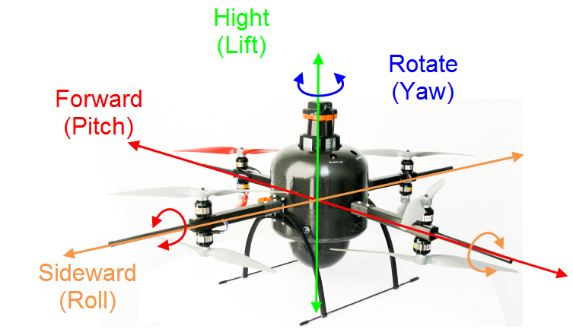

|  |  |  |
| --- | --- | --- |
|  | | |
|  | Left control stick   * Lift/Descent (Gas)   **⬄** Rotate (Yaw) | Right control stick  **⇳** Forward/Backward flight (Pitch)  **⬄** Left/Right flight (Roll) |

|  |  |
| --- | --- |
|  | **Calibration**  Motors have been stopped or not yet been started.   1. Place the Mikrokopter on a horizontally leveled surface (use a water level). 2. Move and hold the left control stick into the upper left corner (listen to three beeps) and wait, until the Mikrokopter responds with a single beep. 3. Move and hold the left control stick into the upper right corner (listen to three beeps) and wait, until the Mikrokopter responds with a single beep. |
|  | **Start motors**  Move and hold the left control stick until all propellers of the Mikrokopter are running properly.  While starting the motors the current GPS position will be saved. |
|  | **Emergency stop**  Moving the left control stick of the remote control will immediately stop all motors.  After an emergency stop the Mikrokopter has to be restarted.  Never stop all motors if the Mikrokopter is flying high. It will crash to the ground immediately. |

|  |  |
| --- | --- |
|  | **Automatic height control**  Switch **SW8** into the „up“ position (seen from the pilot)  **Attention:** Switch off the motors (emergency stop) after each landing and start them again.  **Warning:** Do not switch off the automatic height control while flying. |
|  | **Alignment independent control  (Care free)**  Switch **SW3** into the position “to the pilot”.  *Consequence: The Mikrokopter moves horizontally independent from its current yaw orientation. Horizontal movements will be executed in relation to the pilot position.*  **Attention:** The pilot should not significantly chance his current position. |
|  | **Automatic GPS positions control**  Move switch **SW6/CRTL10/SW7** into the middle position (CRTL10).  *Consequence: The Mikrokopter will automatically hold the horizontal GPS position.*  Using the right control stick may modify the GPS position to hold.  When the right control stick is in the middle position the current GPS position holds.  **Attention:** Automatic GPS positions control works properly only outside of buildings. |
|  | **Switch off the automatic GPS positions control**  Move switch **SW6/CRTL10/SW7** into the „down“ position (SW6).  The automatic GPS position control is switched off.  *Consequence: Mikrokopter horizontal control will be done only manually.* |
|  | **Automatic GPS homing**  Move **SW6/CRTL10/SW7** into the „up“ position (SW7).  *Consequence: The Mikrokopter automatically flies to the position where the motors have been started.*  **Hint:** Automatic GPS positions control works properly only outside of buildings.  **Crash warning The return flight will be performed in a direct manner. The Mikrokopter will not avoid obstacles but will hit them if they are located in the direct flight route.** |